**Android Development Environment**

Download and install Android Studio

The current (and future!) standard for building Android applications

* <https://developer.android.com/sdk/installing/index.html?pkg=studio>

Make sure you have an up-to-date version of Oracle’s Java Virtual Machine (JVM)

* <http://www.oracle.com/technetwork/java/javase/downloads/jdk8-downloads-2133151.html>

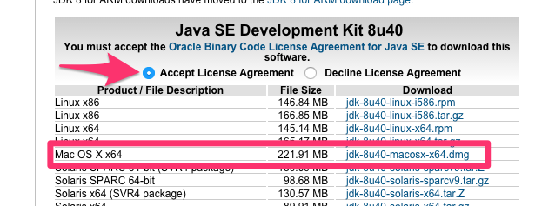

Once Android Studio is installed and you have the JVM downloaded you have enough to create a sample Android app. Let’s start with an easy one!

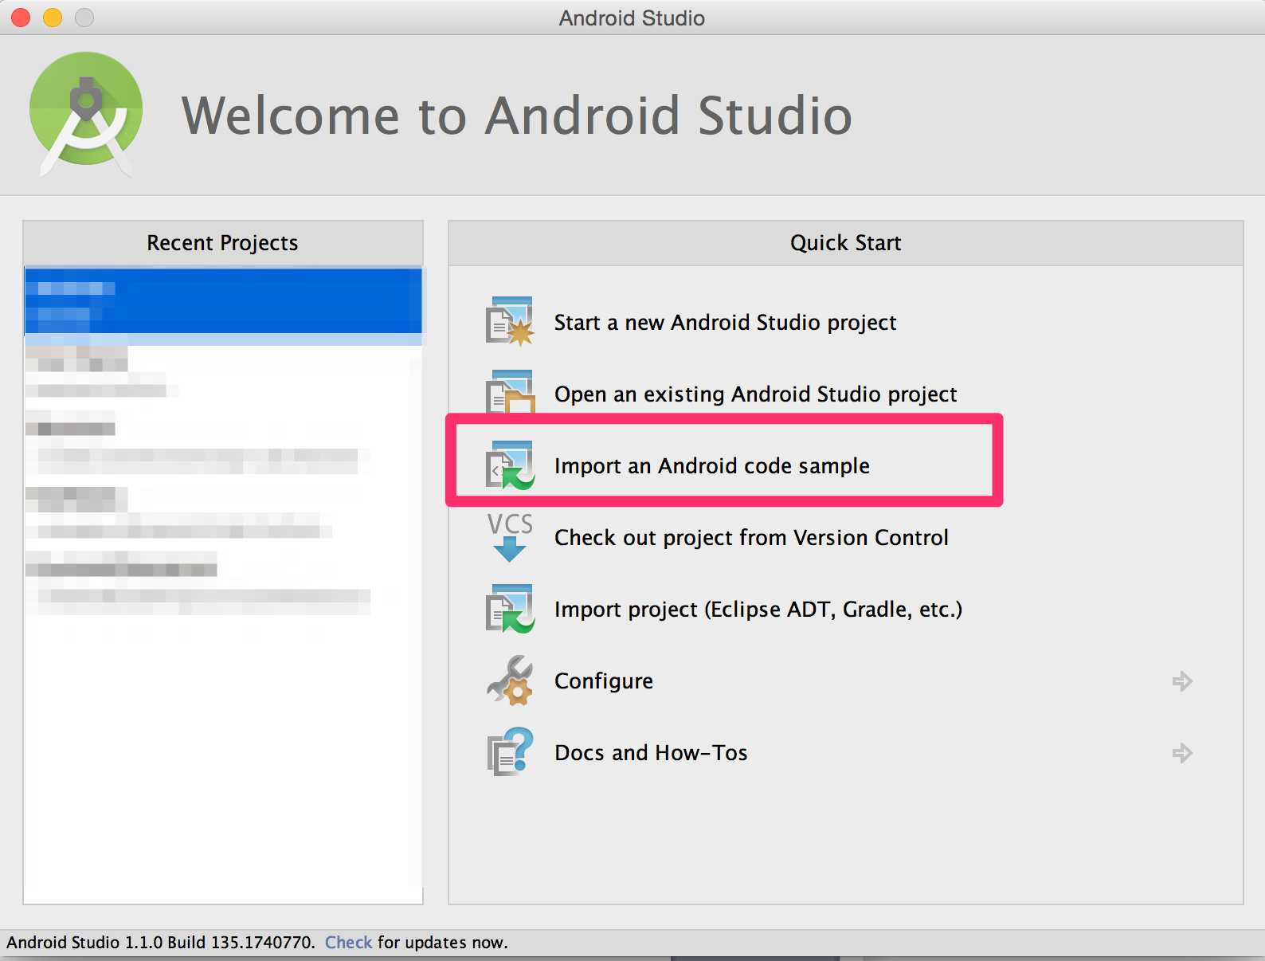 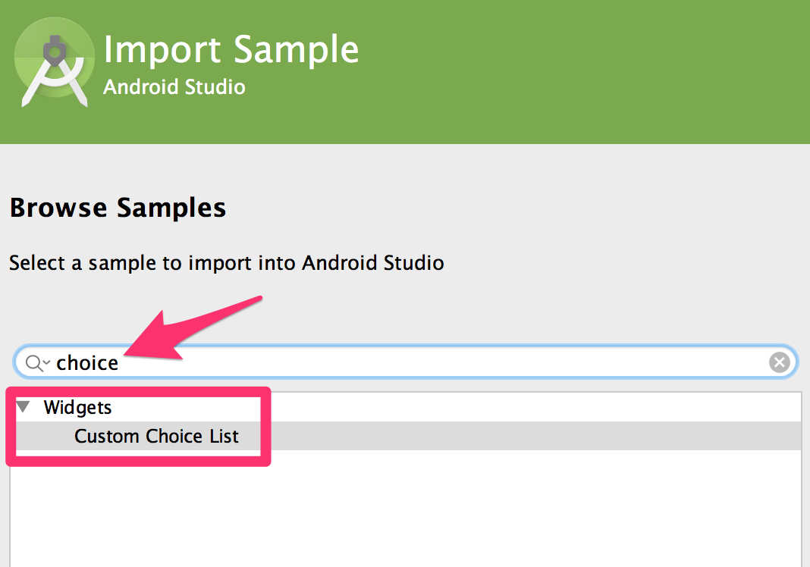

Android Studio will fetch a list of samples to display. Search for the word “choice”

There’s at least one last thing that needs to be done for your project to run. We need to make use of the newer JVM that you downloaded. We do that by changing the Project Structure

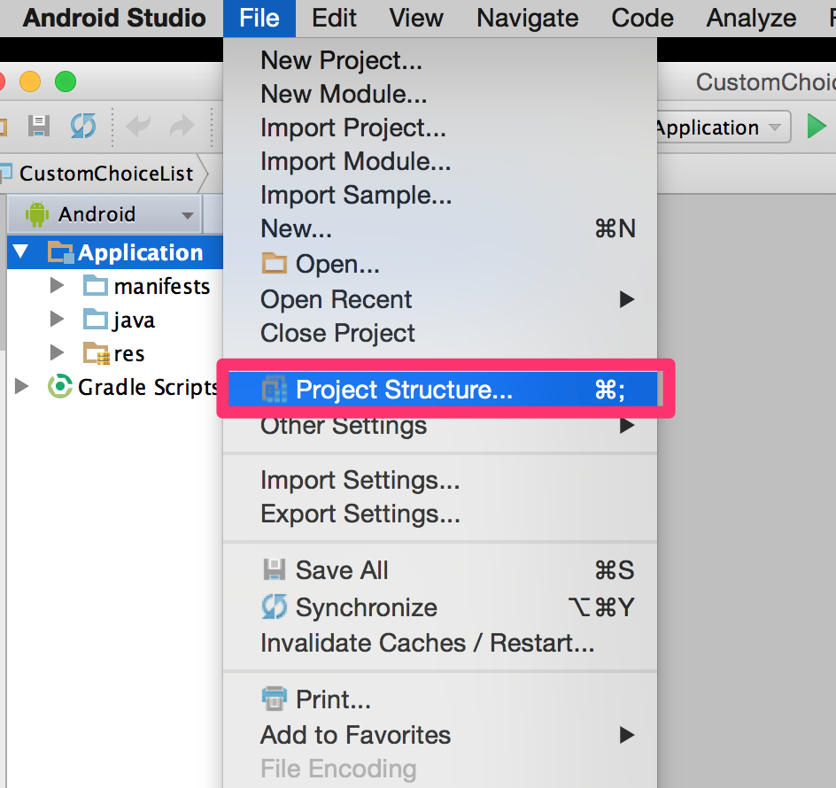

Java 1.8 has changed the default location for the JVM. You need to change the JDK location for your project to

/Library/Java/JavaVirtualMachines/jdk1.8.0_40.jdk/Contents/Home

Now we have sample code and a working environment. Let’s build this app and run it.

Click the button to Sync Gradle files

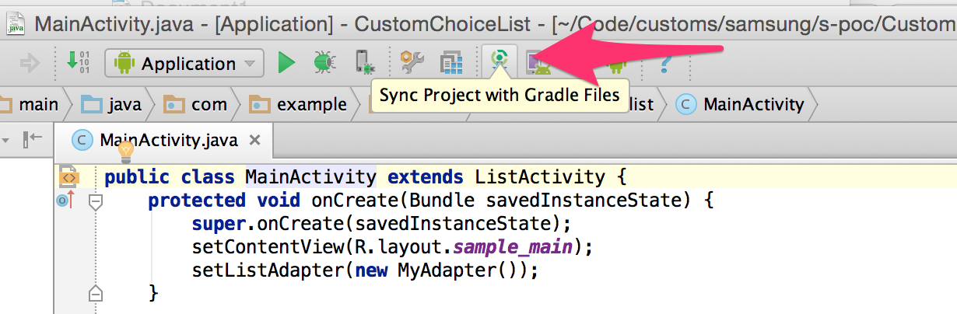

**What *does* Gradle do?**

Gradle is a build program designed to make all the fancy things steps happen along the way from turning the Java you write (and xml and settings and dependencies you link it to) into Java bytecode that a virtual machine can run.

Applications written in Java code get compiled to Java bytecode, which is analogous to Assembly for c/c++. It’s lower level instructions interpreted by a machine, except in this case it’s a Virtual Machine. Android applications run on a special virtual machine called Dalvik.

The functions gradle perform look like this:

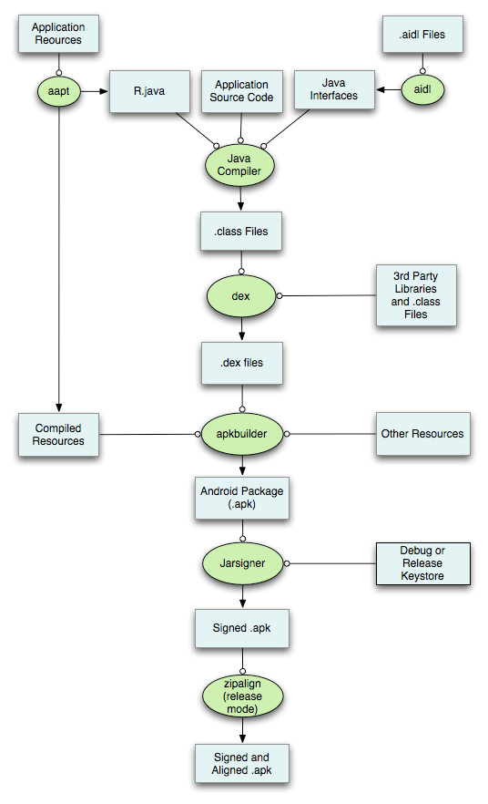

It’s complicated. Be glad it’s there, otherwise you’d have to write build scripts to do all of this yourself.

For this simple example gradle sync should complete without issue. You can then proceed to build the app to run on a device. Hit the Play button:

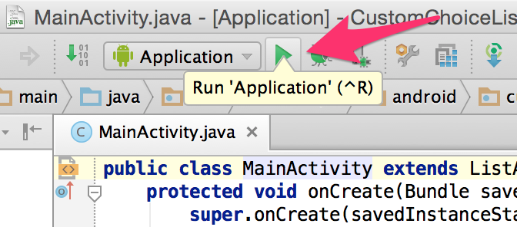

Choose a suitable virtual device and the app will build to it. If you don’t have a virtual device available you can create one in the Android Virtual Device manager(AVD) by clicking the “…” next to the virtual device picker.